**PREREQUISITES** (IBM cloud service, Software)

|  |  |
| --- | --- |
| Date | 22 October 2022 |
| Team ID | PNT2022TMID25653 |
| Project Name | Industry-specific intelligent fire management system |
| Maximum Marks | 8 Marks |

**IBM Cloud Services:**

**We need to have basic knowledge of the following cloud services:**

* IBM Watson IoT Platform
* Node-RED Service
* Cloudant DB

**IBM Account Creation:**

In this we create a account with the register code / promo code using the given mail id at the IBM cloud platform, then login

**IBM CLOUD**

\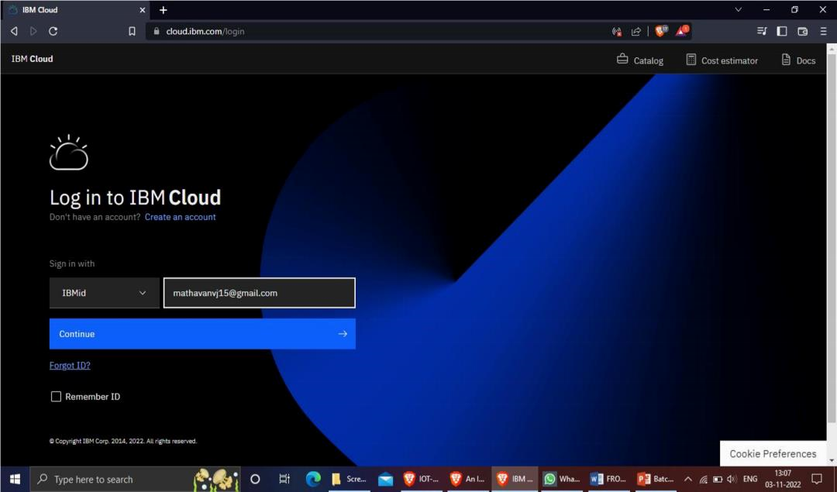

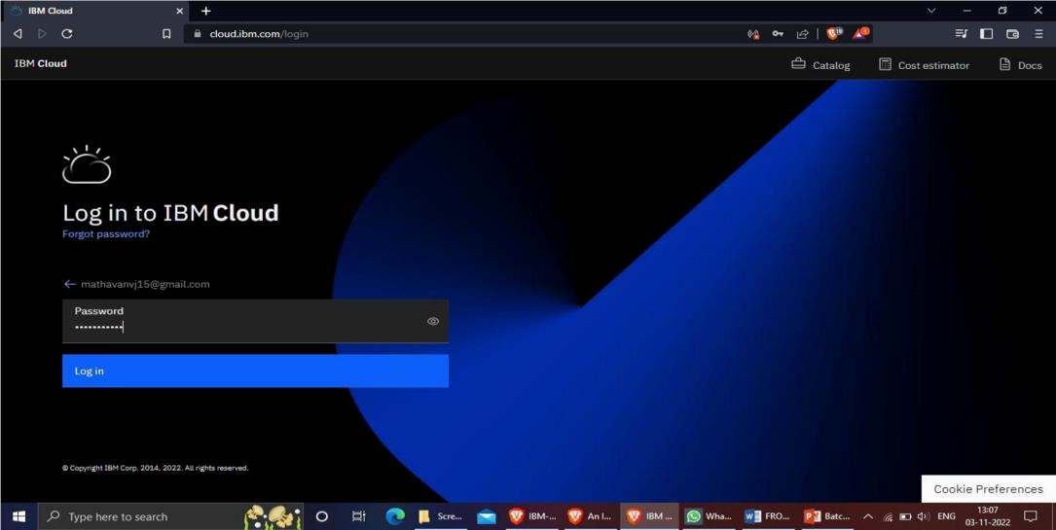

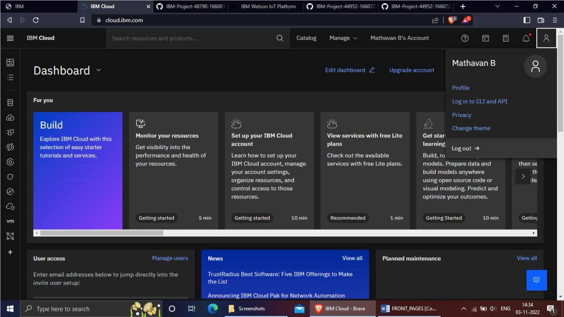

**IBM Watson IoT Platform**

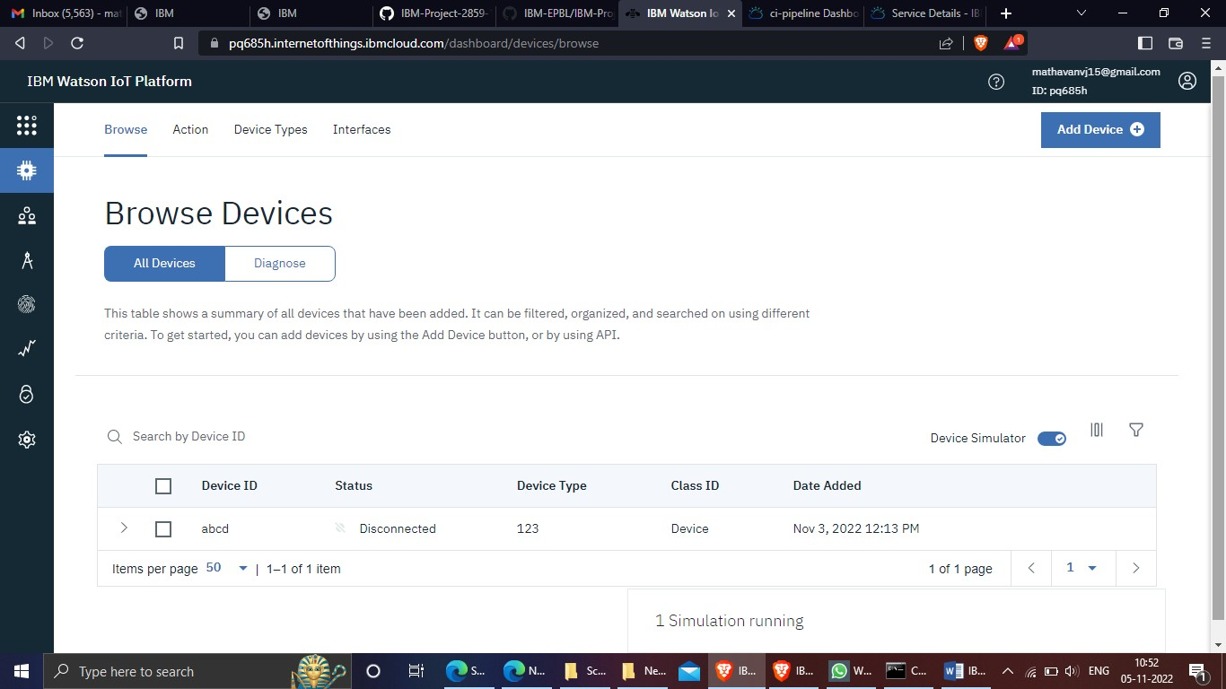

**NODE-RED SERVICE**

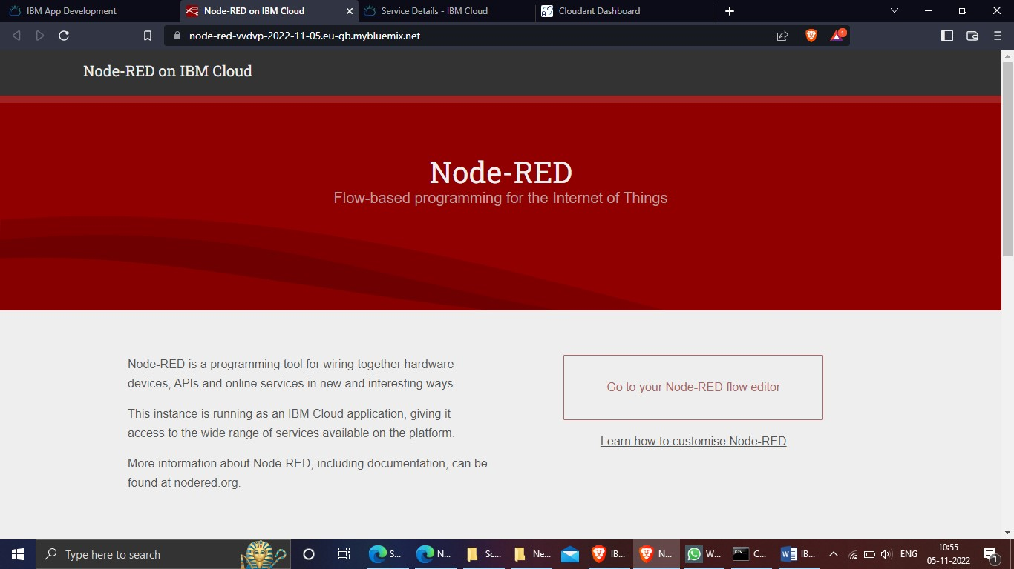

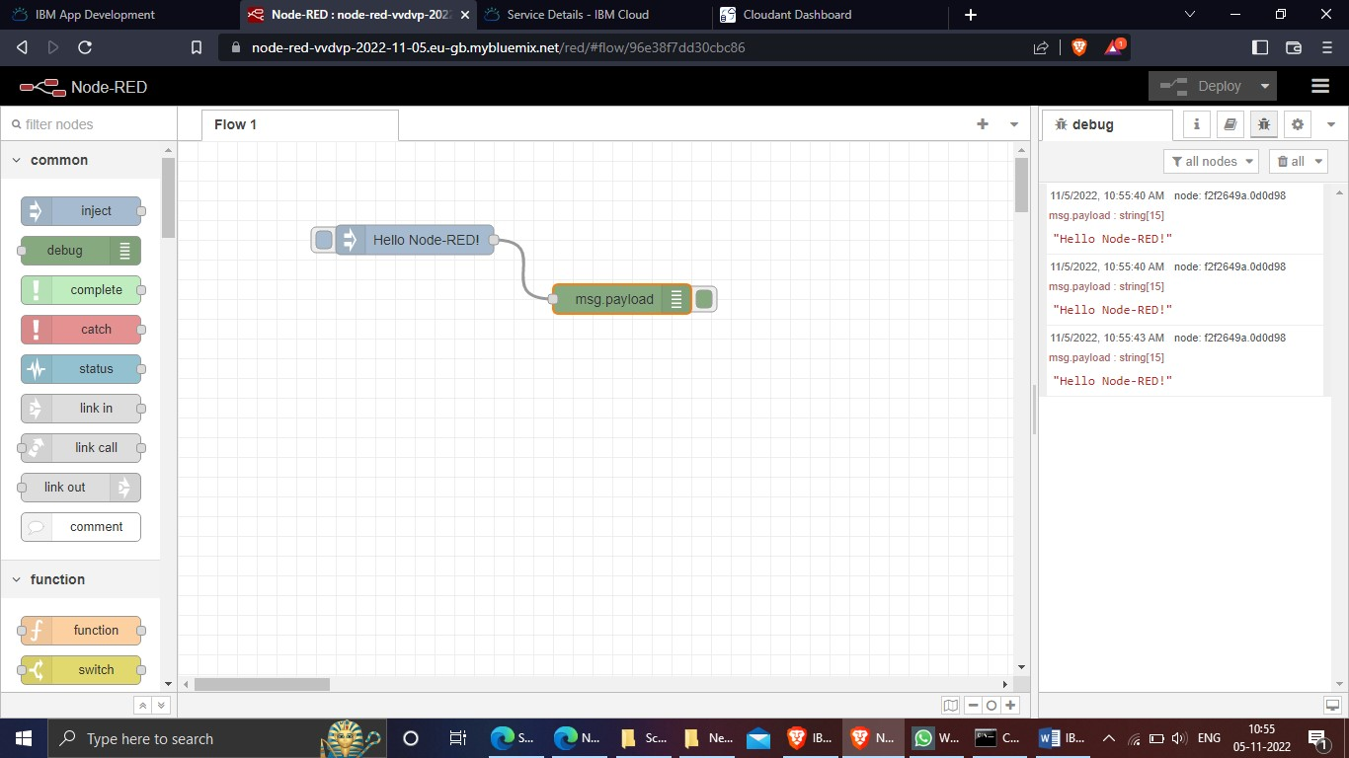

# Cloudant DB

